Kinsmen Booking System — Task 1
Work Breakdown Structure, Data Schema (ERD), and DevOps
INSY7315 — Work Integrated Learning | Team: Kaehil, Kyra, Zario, Gregory

9.1.7 Work Breakdown Structure
The table below breaks the Kinsmen project down into tasks spanning the full development lifecycle, from initial requirements gathering through to the Task 3 EXPO submission. Durations are estimates based on the team's confirmed 4-session plan leading into Task 1, and on the submission dates set out in the module manual.
Task | Description | Duration | Predecessor(s) | Owner(s) | Resources
Send & collect client questionnaire | Gather Kinsmen's business needs, services, and preferences | 5 days | None | Kaehil (sent), all (review) | Questionnaire document, email
Confirm tech stack & architecture | Team decision on MVC, SQL Server, Azure, branching strategy | 1 day | None | All | Meeting time
GitHub repository & pipeline setup | Initialise repo, branch protection rules, initial CI/CD skeleton | 2 days | Tech stack confirmed | Kaehil | GitHub, GitHub Actions
Domain modelling & ERD | Define entities, attributes, and relationships | 3 days | Client requirements received | Zario (Kaehil support) | Diagramming tool, requirements doc
Design class diagram | Translate domain model into implementation-level classes | 2 days | Domain model complete | Zario | UML tool
UX journey map & prototype | Map user flows and screens; build HTML prototype | 5 days | Requirements gathered | Gregory | HTML/CSS, design assets
Architecture & security write-up | Document architecture pattern, design patterns, cloud architecture, security | 3 days | Domain model, tech stack confirmed | Kyra (patterns/security), Zario (architecture), Kaehil (cloud) | Research articles, PRSE notes
DevOps & running costs documentation | Document GitHub workflow, CI/CD pipeline, cost projections | 2 days | GitHub setup complete | Kaehil (DevOps), Kyra (costs) | Azure pricing calculator
Compile & finalise Task 1 documentation | Merge all sections into one PDF, format, proofread | 2 days | All Task 1 sections complete | Kaehil (Gregory support) | Word/PDF tools
Submit Task 1 | Upload documentation and prototype link to ARC | 1 day | Documentation finalised | One team member | ARC portal — due 17 Aug 2026
Database implementation | Build SQL Server schema from ERD, seed test data | 4 days | Task 1 submitted | Kaehil (Zario support) | SQL Server, Azure SQL
Backend API development | Build booking, service, barber, and customer endpoints | 10 days | Database implemented | Zario (Kaehil, Kyra support) | ASP.NET Core, Visual Studio
Front-end development | Build MVC views for booking flow, barber profiles, multi-service selection | 10 days | UX journey map, backend API skeleton | Gregory (Zario support) | HTML/CSS/Bootstrap, Razor views
Automated testing | Unit and integration tests for booking logic and APIs | 5 days | Backend API in progress | Kyra | xUnit, GitHub Actions
CI/CD pipeline completion | Finalise build/test/deploy automation | 3 days | Testing framework in place | Kaehil | GitHub Actions, Azure App Service
Hosting & deployment | Deploy application and database to Azure | 2 days | CI/CD pipeline complete | Kaehil | Azure App Service, Azure SQL
Implementation presentation prep | Prepare demo, slides, technical walkthrough | 2 days | Application hosted and functional | All (Kaehil, Gregory lead) | PowerPoint, live demo environment
Submit Task 2 | Submit GitHub link and README on ARC | 1 day | Presentation prep complete | One team member | ARC portal — due 28 Sept 2026
Final report update & polish | Incorporate Task 1 & 2 feedback into one combined document | 4 days | Task 2 feedback received | Kaehil (all contribute) | Word/PDF tools
User guide creation | Write step-by-step user guide with screenshots | 3 days | Application feature-complete | Kyra (Gregory screenshots) | Screenshot tool, Word
Final bug fixes & polish | Resolve outstanding issues, refine UI/UX | 5 days | Task 2 submitted | Zario, Gregory (Kaehil support) | Visual Studio, Azure
EXPO preparation | Prepare exhibit board, slides, demo script, Q&A prep | 3 days | Application finalised | All | Poster/board materials, PowerPoint
Submit Task 3 | Individual submission of final documentation, user guide, annexures | 1 day | EXPO preparation complete | All (individual) | ARC portal — due Exam Week 1 (TBC)

9.1.11 Data Schema

Choice of technology
The Kinsmen booking system uses Microsoft SQL Server, hosted as an Azure SQL Database, as its primary data store. This choice was made for several reasons:
- Relational structure fits the domain naturally — bookings, barbers, customers, and services have clearly defined relationships (including a many-to-many relationship between bookings and services) that map cleanly onto normalised relational tables.
- ACID compliance is important for a scheduling system, where two customers must never be able to book the same barber for overlapping time slots.
- Native integration with ASP.NET Core via Entity Framework Core reduces boilerplate data-access code and allows the schema to be version-controlled through code-first migrations.
- Azure SQL Database is a fully managed service, which reduces the DevOps overhead of patching and maintaining a database server — important for a small team with a tight timeline.
- The team has prior experience with SQL Server and Entity Framework Core from the GLMS project, reducing the learning curve during implementation.
- Azure SQL offers a free-tier allowance suitable for a student project of this scale, keeping running costs low while the system is in development and early production use.

Entity Relationship Diagram
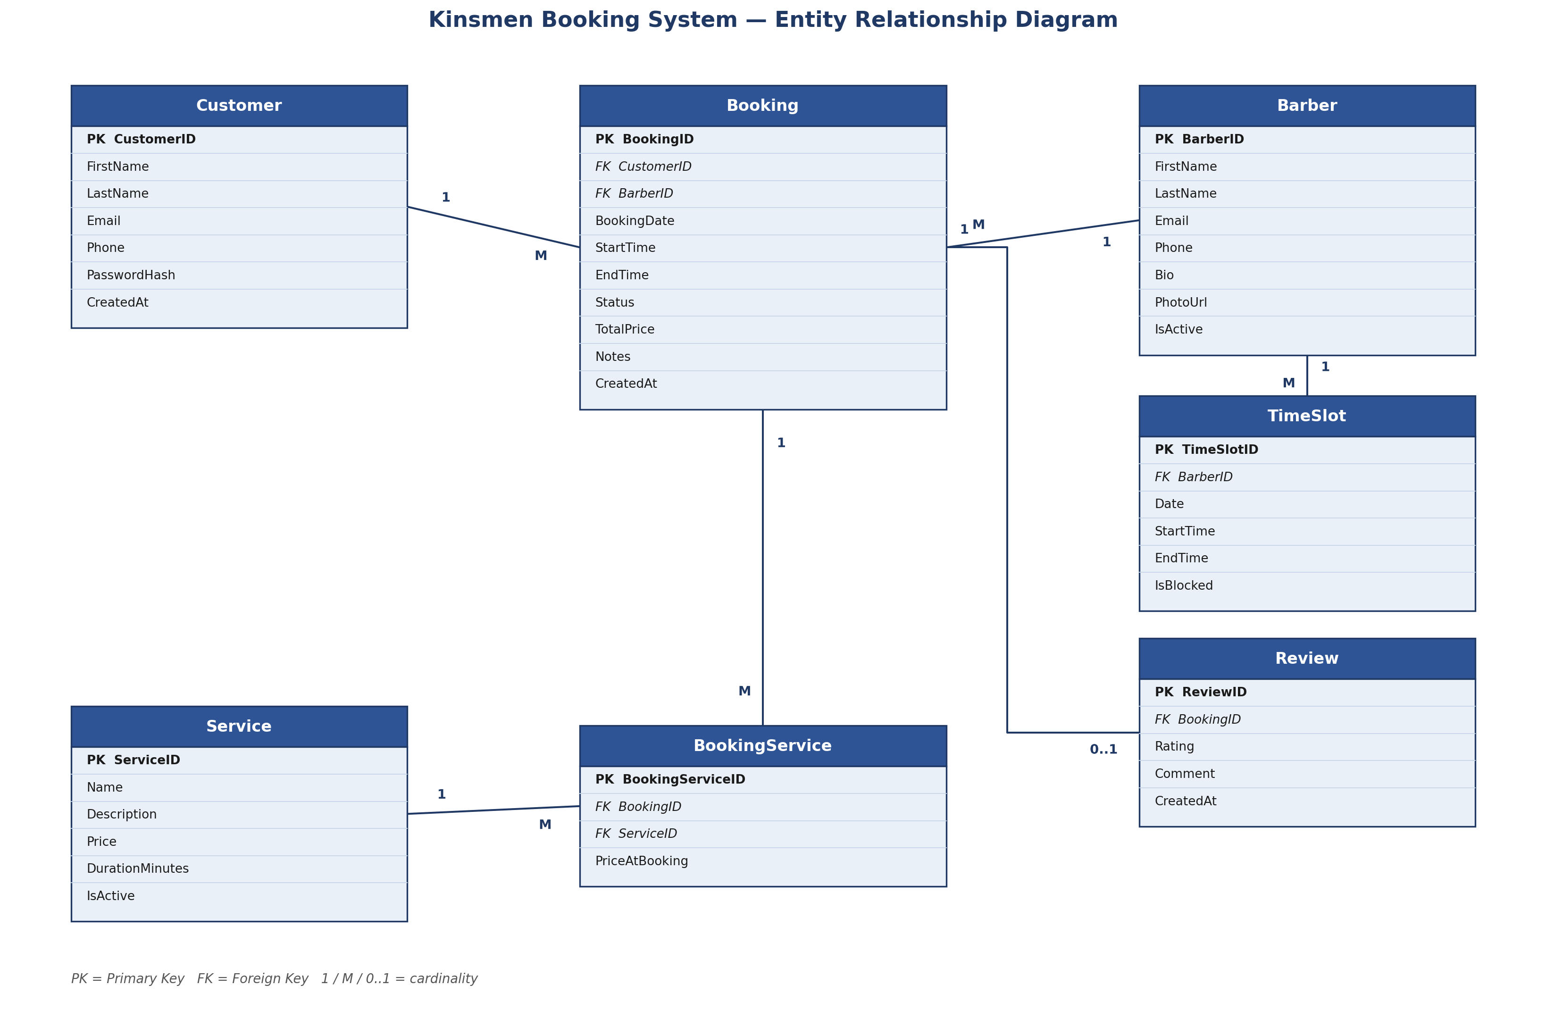
Figure 1: Entity Relationship Diagram — Kinsmen Booking System

Schema description
- Customer — stores customer account details used to make and manage bookings.
- Barber — stores barber profile details, including bio and active status, used for barber selection during booking.
- Service — stores each service offered (e.g. haircut, beard trim), including price and duration.
- Booking — the central entity, linking one customer and one barber to a scheduled appointment. Stores computed totals (price, duration) and status (e.g. Pending, Confirmed, Cancelled, Completed).
- BookingService — a junction table resolving the many-to-many relationship between Booking and Service, since a single booking can include multiple services. Stores the price of each service at the time of booking, so historical bookings remain accurate even if service prices change later.
- TimeSlot — stores each barber's defined availability and blocked periods (e.g. breaks, days off), used to validate that a requested booking time is actually available.
- Review — an optional record linked to a completed booking, allowing a customer to rate and comment on their experience.
Note: a loyalty/points system was discussed as a future enhancement but has intentionally been left out of the current schema, in line with the team's decision to keep this phase's scope realistic. This is addressed further in the Change Management section.

9.1.14 DevOps
Rapid, reliable deployment is central to the success of the Kinsmen booking system, particularly given the team's tight timeline across Tasks 1 to 3. The team has adopted a GitHub-based workflow built around a single protected main branch, individual feature branches, and an automated GitHub Actions pipeline covering both continuous integration (CI) and continuous deployment (CD).

Branching strategy and development flow
- main branch — always reflects a stable, deployable state of the application. Direct commits to main are not permitted.
- feature/* branches — each team member develops their assigned work (e.g. feature/backend, feature/frontend) in an isolated branch, preventing incomplete or breaking changes from affecting the rest of the team.
- Pull Requests (PRs) — once a feature is complete, the owning team member opens a PR targeting main. This triggers the CI pipeline automatically.
- Code review — at least one other team member reviews and approves the PR before it can be merged, catching issues early and spreading knowledge of the codebase across the team.
- Merge — once approved and passing all automated checks, the PR is merged into main, which automatically triggers the CD pipeline.

Automated testing
Automated testing is integrated directly into the CI stage of the pipeline. On every pull request, GitHub Actions restores dependencies, builds the solution, and runs the project's xUnit test suite (covering booking logic, service selection, and API endpoints). A pull request cannot be merged if the build fails or any test does not pass, ensuring that broken code never reaches main.

GitHub Actions Pipeline
The diagram below illustrates the full pipeline, from an individual feature branch through to a live deployment on Azure.
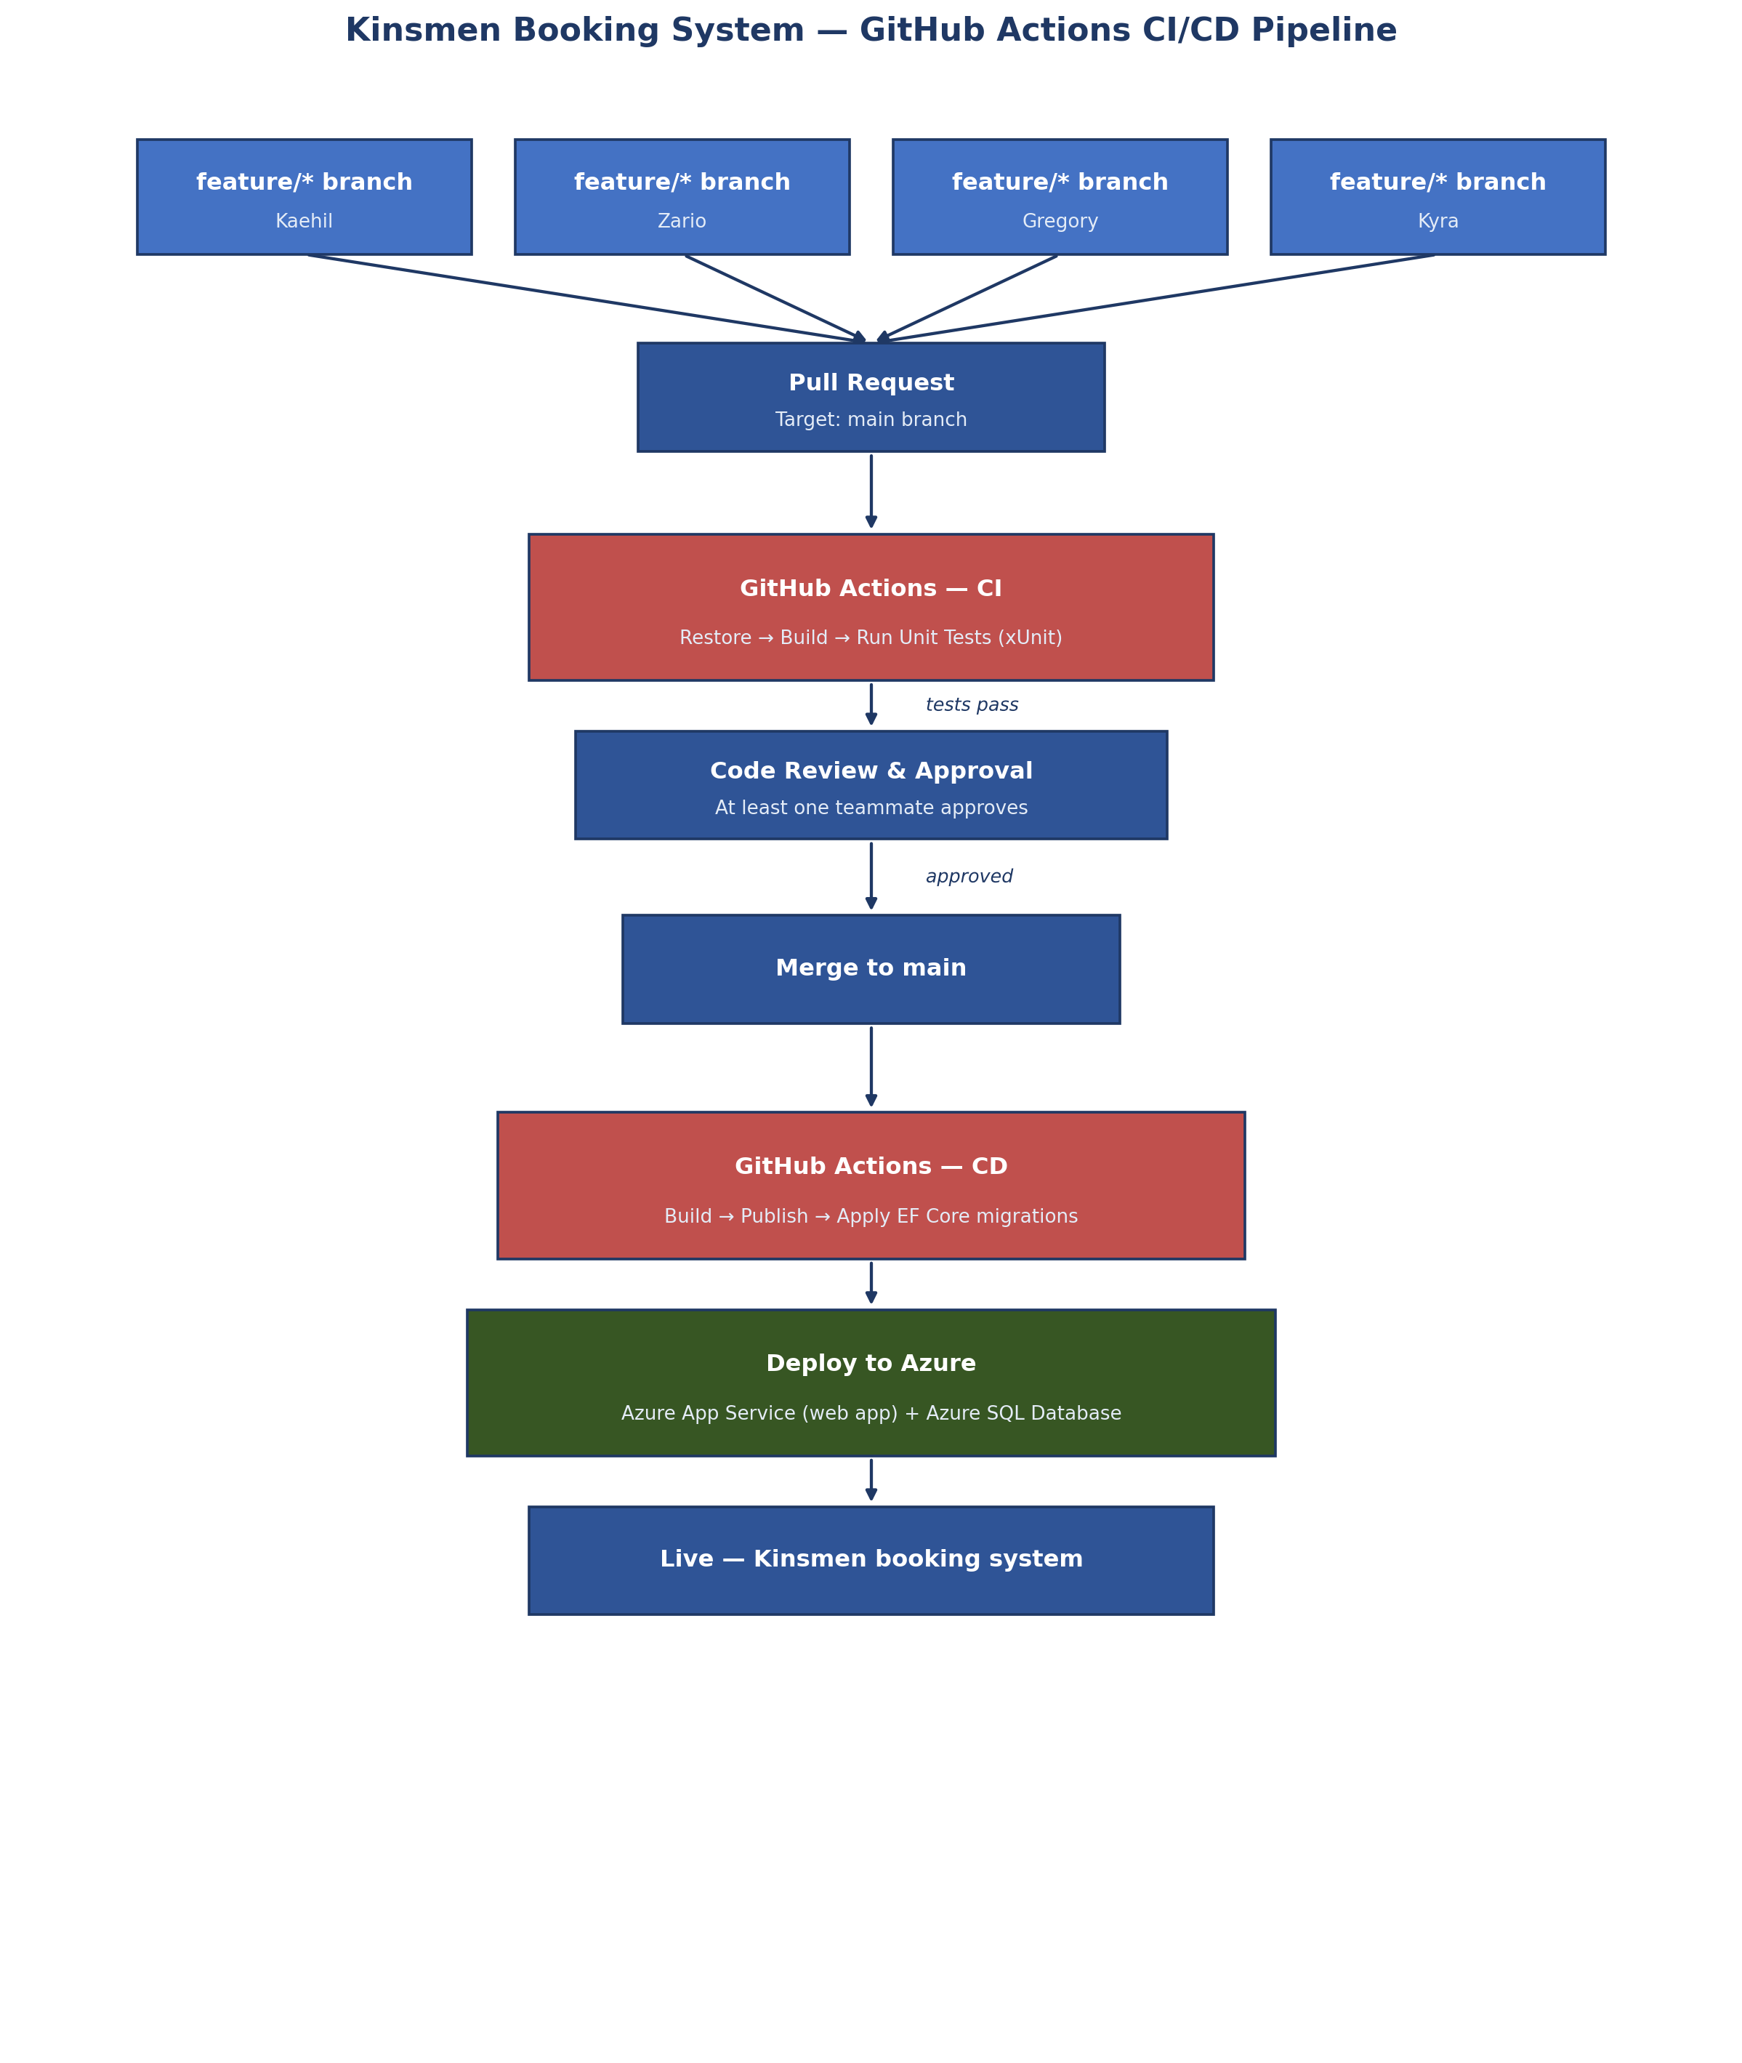
Figure 2: GitHub Actions CI/CD Pipeline — Kinsmen Booking System
As shown above, code changes move through four automated stages: pull request creation, continuous integration (build and test), a human code review gate, and continuous deployment (build, publish, and deploy to Azure). Database schema changes are applied automatically as part of the CD stage using Entity Framework Core migrations, keeping the Azure SQL Database schema in sync with the codebase without manual intervention.

